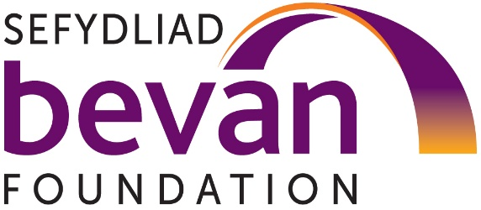
Media release
Embargo: 00.01 Thursday 12th September

Think tank calls on Welsh Government to end silent squeeze on Welsh benefits
Wales’ most influential think-tank, the Bevan Foundation has called on the Welsh Government to uprate help for low income families in line with inflation.
The Welsh Government is responsible for a number of means-tested grants and allowances which complement the UK social security system. These grants and allowances or “Welsh benefits” include Free School Meals, School Essentials Grant and Education Maintenance Allowance and provide a lifeline to low-income families.
Good work is already ongoing within the Welsh Government to make it easier for people to access these benefits through the creation of a Welsh Benefits System. However, the Bevan Foundation has warned that to maximise the impact of this work, the Welsh Government must also commit to increasing the eligibility thresholds and cash values of Welsh benefits in line with inflation.
The Foundation’s Director, Dr Winckler stated:
“The work already ongoing in Welsh Government to establish a Welsh Benefits System has the potential to be a game changer for low-income families across the nation. However, if the Welsh Government is committed to tackling poverty and inequality, to making work pay and to improving the health, wellbeing and educational attainment of the people of Wales then it must also commit to increasing Welsh benefits in line with inflation.”
New research by the Bevan Foundation has shown the impact of the Welsh Government’s decisions over many years to not uprated the cash value and eligibility criteria of most Welsh benefits in line with inflation. Among the Welsh benefits that have been affected have been the School Essentials Grant and Free School Meals in secondary school.
The School Essentials Grant provides a cash grant to children from low-income families towards the cost of school uniform and other equipment. To receive the School Essentials Grant and Free School Meals in secondary school a child’s parent must either receive legacy benefits or Universal Credit, and have an annual net earned household income of less than £7,400. Had the earned household income element of the criteria increased in line with inflation, the threshold would now stand at £9,185.23 a year.
The Bevan Foundation’s Head of Policy (Poverty) Dr Steffan Evans added:
“To be eligible for a Free School Meal in secondary school or the School Essentials Grant, a family would have to be £1,785 a year poorer than in 2019. Another way to look at this is that in 2019, a single parent could work just over 17 hours a week at the National Living Wage and still qualify. Today, the same parent can only work 12.5 hours a week before they are ineligible. This means that no working parent as per the Welsh Government own definition is able to access either scheme.”
The Bevan Foundation has called on the Welsh Government to increase the eligibility thresholds and cash values of all Welsh benefits at least in line with inflation in the 2025/26 budget and thereafter. Where possible the think tank has also called on the Welsh Government to restore eligibility thresholds and cash value of all Welsh benefits to their real terms value at the time they were last uprated, alongside conducting a broader review to ensure that all Welsh benefits are placed on a consistent footing in future.
Steffan Evans added:
“Welsh benefits provide a vital lifeline for families all over Wales and are one of the main tools at the Welsh Government’s disposal to reduce poverty. The Welsh Government’s decision to not uprate the majority of these benefits in line with inflation has put a ‘silent squeeze’ on Wales’ low income families. This squeeze is locking people in real hardship out of the help they need and cutting the value of payments they do receive. They must make sure that they don’t repeat this mistake this autumn.”
Ends.
Note to editors
The Bevan Foundation is Wales’ most influential think-tank. We create insights, ideas and impact that help to end poverty and inequality. We are independent, informed, inspiring and inclusive in everything we do.
The Foundation is a registered charity no. 1104191 and funded by a mix of charitable trusts and foundations, donations from individuals and trading.
This report is part of a broader project of work developed in collaboration between the Bevan Foundation and the Joseph Rowntree Foundation. For more information on this work click here.
A copy of the full report is attached
Contact
For comment in English or Welsh contact Dr Steffan Evans on steffan.evans@bevanfoundation.org or 07794946550

